Master of Arts Counseling

Clinical Skills Workbook

Mee-Gaik Lim, Ph.D, LPC-S, LMFT-S
Brandi Aguirre, MA
Bethany Colegrove, BA

Table of Contents

Foundations/Introduction
Feelings List | 3
Feelings: Level of Intensity | 5
Empathic Response Worksheet | 7
Desired Behaviors and Feeling | 11
Question Development Worksheets | 13
Content and Process Development | 16
Case Conceptualization Worksheet | 17
Empathic Responses  Empathic Response Leads | 18  19
Open-ended Probe Questions | 21
Application/Advanced
Goals and Objectives | 23
Sample Case Studies | 24
Theories Matrix | 30
Case Application Worksheet | 37
Exploration
Deepening Process | 40
Video Evaluation | 41
Tips In Session | 43
Mind Maps | 44
Genograms | 46
At A Glance/Appendix
Emotions and Feelings – A List of Choices | 49
Introductory Stems to Start Goals, Objectives and Open-ended Questions | 49
Case Studies | 52
References | 53

Foundations/Introduction

Feelings List
Instructions: Identify multiple feelings and emotions for each letter of the alphabet.
Alphabet List | Feeling
A

B

C

D

E

F

G

H

I

J

K

L

M

N

O

P

Q

R

S

T

U

V

W

X

Y

Z

We must not allow other people’s limited perceptions to define us…………Virginia Satir
Feelings: Level of Intensity
Instructions: Select from the feeling list on page 46 a feeling/emotion for each letter of the alphabet and identify the moderate and intense form of that feeling.

Moderate | Initial Feeling | Intense
Upset | A  Angry | Enraged
 | B
 | C
 | D
 | E
 | F
 | G
 | H
 | I
 | J
 | K
 | L
 | M
 | N
 | O
 | P
 | Q
 | R

S

T

U

V

W

X

Y

Z

Doing what you love is the cornerstone of having success in your life………….Wayne Dyer
Empathic Response Worksheet
Instructions: Select any 15 feeling words and construct empathic responses. Ensure that each empathic response has these three elements in it:
--identify and reflect the feeling
--state the desired feeling or behavior
--construct an open-ended question to probe further into the identified feeling or core themes.

Use open-ended questions:
- Tell me more about...
- Help me understand...
- Explain your thoughts on...
- It appears that you are concerned about...
- What do you....
- Talk about your concern…
- What do you see.….
- Paint a picture…..

Example 1:
Feeling: Angry
Empathic Response: It appears that you are angry at your mother's preferential treatment of your sister and it is important that she treats both of you fairly and equally.
Question: Tell me more about how you would like your mother to treat you fairly and equally.

Example 2
Feeling: Afraid
Empathic Response: It appears that you are afraid of the "unknown" when your parents divorced and you were seeking for assurances of emotional safety from them.
Question: Talk about what would help you feel safe and secure during your parent’s divorce.

1 | Feeling:  Empathic Response:  Question:
2 | Feeling:  Empathic Response:  Question:
3 | Feeling:  Empathic Response:  Question:
4 | Feeling:  Empathic Response:  Question:
5 | Feeling:  Empathic Response:  Question:
6 | Feeling:  Empathic Response:  Question:
7 | Feeling:  Empathic Response:  Question:

8 | Feeling:  Empathic Response:  Question:
9 | Feeling:  Empathic Response:  Question:
10 | Feeling:  Empathic Response:  Question:
11 | Feeling:  Empathic Response:  Question:
12 | Feeling:  Empathic Response:  Question:

13 | Feeling:  Empathic Response:  Question:
14 | Feeling:  Empathic Response:  Question:
15 | Feeling:  Empathic Response:  Question:

It is not easy to find happiness in ourselves, and it is not possible to find it elsewhere....
Agnes Repplier
Desired Behaviors and Feelings
Instructions: Select any 15 negative feelings or behaviors to develop desired approach framework, growth-promoting dialog and resource focused responses.

Sample Feelings and Behaviors:
scared mad afraid frightened
ashamed fearful lonely threatened
frustrated panicky withdrawn explosive
destructive crushed intimidated jealous

Client's NEGATIVE feelings and behaviors  - Use of avoidance framework  - Growth-limiting dialog  - Limitations focus |  | Client's DESIRED feelings and behaviors  - Use of approach framework  - Growth-promoting dialog  - Resource focus
Examples:  I want to stop avoiding or skirting around my problems.  I want to stop asking others to handle my problems for me.  I do not want to hide behind my husband’s shadow in social settings.  I want to stop smothering my children. |  | It appears that you want to start dealing with problems and confront them.  It sounds like you want to start taking initiative for concerns that arise.  It appears that you are ready to let your true identity emerge in social settings.  It seems like you would like to give your children space to make their own decisions.
1.
2.
3.
4.

5.
6.
7.
8.
9.
10.
11.
12.
13.
14.
15.

Question Development
Worksheet for Case 1

Instructions: Using the case studies from page 50, identify core themes and feelings that will guide you in generating open-ended, positively stated questions.
Identify Core Themes, Feelings, Emotions of Client | Generate Ten Open-ended Questions
Identify Core Themes, Feelings, Emotions of Client | -Tell me more about...  -Help me understand...  -Explain your thoughts on...  -What do you...  -Talk about your concern…  -Paint a picture….. | -Explore…  -Clarify…  -How…  -What else…  -Describe…  -Elaborate…

Question Development
Worksheet for Case 2

Identify Core Themes, Feelings, Emotions of Client | Generate Ten Open-ended Questions
Identify Core Themes, Feelings, Emotions of Client | -Tell me more about...  -Help me understand...  -Explain your thoughts on...  -What do you...  -Talk about your concern…  -Paint a picture….. | -Explore…  -Clarify…  -How…  -What else…  -Describe…  -Elaborate…

Question Development
Worksheet for Case 3

Identify Core Themes, Feelings, Emotions of Client | Generate Ten Open-ended Questions
Identify Core Themes, Feelings, Emotions of Client | -Tell me more about...  -Help me understand...  -Explain your thoughts on...  -What do you...  -Talk about your concern…  -Paint a picture….. | -Explore…  -Clarify…  -How…  -What else…  -Describe…  -Elaborate…
Clinical Application
CONTENT | The client’s story and symptoms  Ex: Student is failing academic coursework and demonstrating defiant behaviors. Student states frustration towards parents.
PROCESS | Core issues, themes, patterns, dynamics  Examples:  Lack of parental cohesiveness  Lack of structure  Weak parental subsystem
Content and Process Development
Instructions: Identify the differences between content and process. Use this worksheet to develop the themes, goals and questions for various case studies.

Case Conceptualization Worksheet
Client’s NEGATIVE feelings and behaviors | Client’s DESIRED feelings and behaviors
Fearful | To take on responsibility.
Themes/Patterns/Dynamics | Approach Goals
Avoid problems; fearful of making choices and taking responsibility | To strengthen core self; To improve true identity

Empathic Responses
Instructions: Using the case studies from page 50, generate empathic responses.
Ex #1: It appears that you have felt a lack of intimacy with others in your life and are looking to strengthen and build positive connections.

Ex #2: It seems that you have been involved in a lot of self sabotaging behaviors and are looking to build positive skills within yourself.

1. _________________________________________________________________
___________________________________________________________________
2._________________________________________________________________
___________________________________________________________________
3._________________________________________________________________
___________________________________________________________________
4._________________________________________________________________
___________________________________________________________________
5._________________________________________________________________
___________________________________________________________________

Know thyself means this, that you get acquainted with what you know, and what you can do……..
Menander

Empathic Response Leads

Kind of feeling....

Sort of a feeling that....

Sort of saying. . . .

As I get it, you felt that....

As I get it, you're saying....

I'm picking up that you....

If I'm hearing you correctly

To me it's almost like you're saying....

Kind of made (makes) you feel....

The thing you feel the most right now is sort of like....

So, you feel...

So, as you see it…

As I get it, you're saying....

What I guess I'm hearing is....

I'm not sure I'm with you, but....

I somehow sense that perhaps you feel....

You feel....

I hear you saying....

What I hear you saying....

I really hear you saying....

I wonder if you're expressing a concern that....

It sounds as if you're saying you....

I wonder if you're saying you....

You place a high value on....

It seems to you....

Like right now....

You feel, perhaps....

Sometimes you think....

Could it be that....

You appear to be feeling....

It appears to you....

As I hear it, you....

This could be along shot, but....

So, from where you sit....

Your feeling at the present time is that....

I read you as....

You must have felt....

I sense that you're feeling....

Very much feeling…

Your message seems to be

Listening to you it seems as if…

You appear....

I gather....

So your world is a place where you ...

You communicate (you convey) the sense that…

Open-ended Probe Questions
Instructions: Using the case studies from page 50, generate open-ended probing questions.
Introductory probes to start open-ended questions: Clarify….; Describe….; Elaborate….; Explain…; Explore….; Help me to understand….; How….; Paint me a picture….; Share….; Talk about….; Tell me about…; What….; What does….; What else….;
1. __________________________________________________________________
___________________________________________________________________
2._________________________________________________________________
___________________________________________________________________
3._________________________________________________________________
___________________________________________________________________
4._________________________________________________________________
___________________________________________________________________
5._________________________________________________________________
___________________________________________________________________

Application/Advanced

Goals and Objectives
- A goal is a statement that describes in general terms what the learner will gain from instruction.
- An objective is a statement in specific and measurable terms that describes what the learner is expected to know or be able to do as a result of the learning experience.
- The goal is where you want students to be at the end of the course. The objectives are the steps they will take to get there.

Differences Between Goals and Objectives:
Goals | Objectives
Broad  General intentions  Intangible  Abstract  Cannot be validated or measured as stated | Narrow  Precise  Tangible  Concrete  Can be validated or measured

Comparison of Goals and Objectives
- Example Goal: The student will gain a greater appreciation for Latin music.
- Example Objective: The student will identify five different Latin American rhythms from the recordings posted on the course website.
Introductory Stems to Start Approach Goals
To improve…  To understand…  To communicate…  To strengthen…  To explore…  To implement…  To educate… | To stabilize…  To establish…  To utilize…  To explain…  To develop…  To increase…  To accept…  To achieve… | To discover…  To foster…  To motivate…  To build…  To maintain…  To enhance…  To resolve…

Sample Case Study
Julie: “It’s my father’s fault I can’t trust men”
Theoretical Perspective: Cognitive-behavior Therapy
- Problems may be rooted in childhood, but are reinforced by present thinking.
- Internal dialogue plays a central role in behavior.
- Focus on examining faulty assumptions and misconceptions and replace them with effective beliefs.
- Focuses on the immediate present; what and how a person thinks is more important than why a person thinks that way.
- Common techniques in CBT:
  - Self-monitoring
    - Client writes down their thoughts to certain situations especially hose bringing them anxiety or other upset feelings.
  - Cognitive restructuring:
    - Help client to gather evidence against the previous evaluations from self-monitoring.
  - Behavioral activation
    - Have the client go into situations where he or she may contact something that was once feared.
    - By encountering something that was once feared and not experiencing any negative outcomes, the person will have more evidence that their previous thoughts were not accurate.
- Sessions are quite structured.
- Emphasize the role of homework.
- Place responsibility on the client to assume an active role both during and outside of the therapy sessions.
Goals of theory:
- To help client learn to recognize negative patterns of thought, evaluate their validity, and replace them with healthier ways of thinking.
- To help the client recognize how their negative patterns of thought affect their mood, behavior, and physical condition.
- To teach coping skills, such as problem solving and scheduling pleasurable experiences.

Long Term Goals:
- Implement a way to recognize patterns of thought and evaluate their validity.
  - Short Term Objectives:
    - Identify ways Julie can track her thoughts through self-monitoring.
    - Investigate the validity of Julie’s generalization of men.
  - Therapeutic Questions:
    - Elaborate on ways that can keep you a record of your thoughts (Objective 1).
    - What else can you do to monitor your thoughts long-term (Objective 1)?
    - Tell me about at least one man that you have been able to trust with whom you have not had a romantic relationship with (Objective 2).
    - Describe what that relationship was like and how you were able to build that trust (Objective 2).
- Understand thoughts affect mood, behavior, and physical condition.
  - Short Term Objectives:
    - Identify ways in which thoughts, both positive and negative, affect mood.
    - Demonstrate that Julie’s thoughts towards men affect her behavior.
  - Therapeutic Questions:
    - Tell me how your thoughts about men affect your current behavior (Objective 2).
    - Paint for me a picture of how your mood would be affected if you were able to trust men (Objective 1).
    - Paint for me a picture of how you think you would feel and behave if you were able to trust a man (Objective 1 and Objective 2).
    - Elaborate on the kinds of social activities you would partake in if you were more trusting (Objective 1 and Objective 2).
- Resolve Julie’s assumptions through behavioral activation.
  - Short Term Objectives:
    - Develop a list of locations where Julie feels safe trusting men.
    - Replace Julie’s assumptions with healthier ways of thinking.
  - Therapeutic Questions:
    - Help me to understand how you can come to be trusting of a man (Objective 2).
    - Paint for me a picture of what type of environments you feel safe trusting men (Objective 1).
    - What kind of things do you do socially and describe your level of comfort with men at those locations (Objective 1)?
    - Explore for me what is a healthier way for you to think about men.

- To strengthen Julie’s coping skills, such as problem solving and scheduling pleasurable experiences.
  - Short Term Objectives
    - Develop a plan to cope with future occasions in which her trust in men will be questioned again.
    - Explore comfortable coping methods.
  - Therapeutic Questions:
    - Describe for me how you currently cope with difficult situations and how you would like to see that change (Objective 1 and Objective 2).
    - Tell me about your plan to continue self-monitoring of your thoughts and how that will assist you with putting healthier thoughts and actions into play (Objective 1).
    - Describe for me a situation in which you have successfully used problem solving techniques and how you can use those same techniques in your future relationships with men (Objective 1 and Objective 2).
    - Help me to understand how you plan to cope with future issues with trust following the end of your therapy (Objective 1).

Sample Case Study
Jack: Afraid that he is “empty inside”
Theoretical Perspective: Reality Therapy
- People are capable of changing their lives and are completely responsible for their choices.
- People are motivated to satisfy one or more of their five basic needs:
  - Survival
  - Love (belonging, connectedness)
    - More emphasis is placed on this need as humans require this need to satisfy their other needs.
  - Power (achievement)
  - Freedom (independence)
  - Fun
- Reality therapist would only focus on the past to discuss previous successes because a person’s needs can only be met in the present and revisiting the past is of no benefit to the client or the counselor.
- Most clients are either involved in a present unsatisfying relationship or lack what would even be considered a relationship. Their problems are caused by an inability to connect with others or to have a satisfying or successful relationship with at least one of the significant people in their lives.
- Almost all behavior is chosen and clients choose their behavior as a way to deal with the frustration caused by their unsatisfying relationships.
Goals of Theory:
- Empower the client to make their own choices and be responsible for those choices.
- Help the client evaluate their needs and wants, their current behaviors, and their future plans.
- Identify which of the five basic needs are not being met and how can the counselor assist the client in choosing more effective behaviors that would help them to meet their own needs.
Long Term Goals:
- To establish a successful or satisfying relationship with at least one significant person in Jack’s life.
  - Short Term Objectives:
    - Identify ways in which Jack can nurture close and intimate relationships with others.
    - Verify how the improved connections with others will increase Jack’s satisfaction.
  - Therapeutic Questions:
    - Describe what actions you think are necessary to bring people closer to you (Objective 1).
    - Illustrate what a successful relationship would look like to you (Objective 1).
    - Tell me how you would feel if you were more connected with others as a result of being more vulnerable (Objective 2).
    - Explain to me what you can do to show someone else your warm, sensitive side (Objective 1).
- To explore alternative behaviors that will help Jack deal with frustration caused by future unsatisfying relationships.
  - Short Term Objectives:
    - Differentiate between alternative behaviors that are healthy as opposed to self-destructive that will aid in dealing with frustrations caused by future unsatisfying relationships.
    - Identify alternative behaviors that will promote togetherness as opposed to isolation.
  - Therapeutic Questions:
    - Help me understand what you like to do for fun (Objective 1).
    - List healthy behaviors that can be used to help you deal with stress and frustration (Objective 1).
    - Elaborate on what specific activities you would be able to do with others that you would find enjoyable (Objective 1 and Objective 2).
    - Share with me what kind of activities you can be involved in that would make you feel less “empty inside” (Objective 1).
- To strengthen Jack’s ability to evaluate and effectively meet his own basic psychological needs.
  - Short Term Objectives:
    - Identify which of the following basic psychological needs are not currently being met: power, freedom, and fun.
    - Compose a plan that will enable Jack to better meet the needs in which he is currently experiencing deficiencies.
  - Therapeutic Questions:
    - Clarify how you have satisfied your basic need for power and achievement (Objective 1).
    - Tell me what actions you are currently taking to meet your need to be free and independent (Objective 1).
    - Describe to me what actions you can be taking to better satisfy your basic needs (Objective 2).
    - Share with me how you can ensure that you follow through with some of those actions (Objective 2).
- To educate Jack on the importance of taking responsibility for making effective choices for himself.
  - Short Term Objectives:
    - Identify ways making effective choices will improve the quality of relationships with others.
    - Recognize ways to make effective choices even when relationships are not successful.
  - Therapeutic Questions:
    - Name some specific ways making effective choices can impact your relationships in a positive way (Objective 1).
    - Explain to me several positive lessons that can be gained from a relationship that has concluded (Objective 2).
    - Describe how those positive lessons can help you make more effective choices in the relationships that follow (Objective 1).
    - Paint me a picture of what an effective choice would look like when you are faced with a future unsatisfying relationship (Objective 2).

Summary of Counseling Theories
Theory | Theorist | Theoretical Concepts | Goals | Therapeutic Interventions
Individual
Psychology

Person-
Centered

Existential

Theory | Theorist | Theoretical Concepts | Goals | Therapeutic Interventions
Gestalt

Rational
Emotive

Cognitive

Theory | Theorist | Theoretical Concepts |  | Goals |  | Therapeutic Interventions
Cognitive/
Behavioral

Reality

Solution-Focused
Brief

Summary of Marriage and Family Theories
Theory | Theorist |  | Theoretical Concepts |  | Goals |  | Therapeutic Interventions
Psychodynamic

Experiential

Trans-generational

Theory | Theorist | Theoretical Concepts |  | Goals |  | Therapeutic Interventions
Structural

Strategic

Milan

Theory | Theorist | Theoretical Concepts | Goals | Therapeutic Interventions
Cognitive/
Behavioral

Social Constructionist

Narrative

Theory | Theorist | Theoretical Concepts | Goals | Therapeutic Interventions
Psycho-educational

Case Application Worksheet
Instructions:
Provide a brief description of the presenting problem: Describe behaviors and symptoms presented by the client.
Demographics and development history: Provide information related to social and economic environment, marital status, employment status, family relationships, leisure activities, religious orientation, support systems, etc.
Family genogram: Draft a simple genogram of the family to help us understand the dynamics and themes of the case (triangles, cut-offs, secrets, myths, gender roles, conflictual relationships, etc)
 | Theory of Choice | Clinical Case
Concepts

Healthy individual

Goals

Interventions

Questions

Exploration

Deepening Process
Initial probing questions & reflections
3
1
2
4
Advanced probing, questioning, and reflections

1. Tell me how you would feel if you were more connected with others.
2. How will life be different for you if you feel fulfilled?
3. Describe what actions you have taken to fulfill a sense of belonging.
4. Clarify how you have maintained a sense of power in your life.

Video Evaluation
Asked open-ended questions | Examples:
Questions were positively stated | Examples:
Process:
- Identified themes
- Patterns
- Dynamics
- Family-of-origin patterns

Percentage of client/counselor interaction (ex: 70/30)  The client is doing 70 % of the work while the counselor is asking questions, probing, reflecting 30% of the session. | ________________/____________________  Client Counselor
Is the session client focused or other focused (ex: family member, significant other, etc)?

Theory identification:
What theoretical questions and interventions were implemented?

Identify questions that have the client take responsibility for his/her behavior or actions.  ---------------------  State opportunities for client to take ownership for his/her behaviors or actions.  ---------------------  What is the counselor doing to promote emotional growth and accountability in client? | ---------------------  ---------------------
Deepening process:
Determine level of questioning
(beginner, intermediate, or advance).
Suggestions for counselor improvement and growth.

Tips In Session
Present welcoming and empathic demeanor.
Ask open-ended, positively stated questions.
Identify themes, patterns, and dynamics.
To deepen the session, ask questions at the advanced level.
Ensure the session is client-focused.
Infuse appropriate theoretical questions and interventions.
Percentage of client-counselor interaction: It is highly suggested that a client should participate in 70% of the work during a session. The counselor should not “chase” the client.

Additional notes:
______________________________________________________________________________________________________________________________________________________________________________________________________________________________________________________________________________________________________________________________________________________________________________________________________________________________________________________________________________________________________________________________________________________________________________________________________________________________________________________________________________________________________________________________________________________________________________________________________________________________________________________________________________________________________________________________________________________________________________________________________________________________________________________

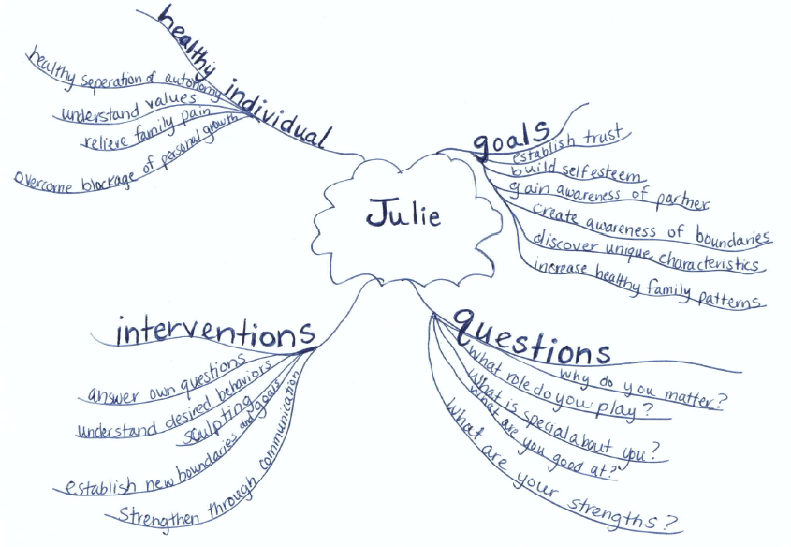
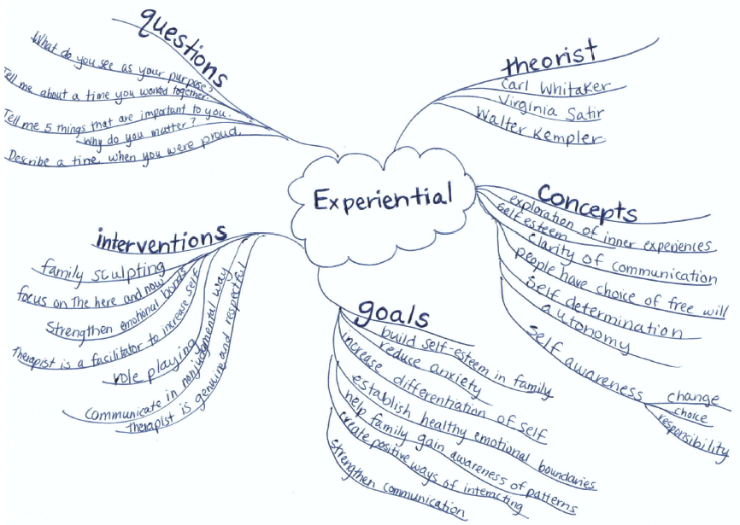
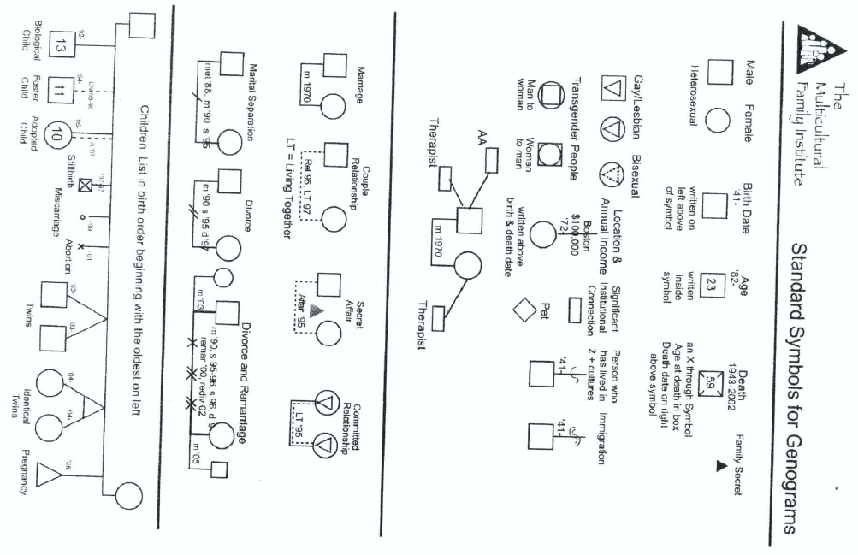
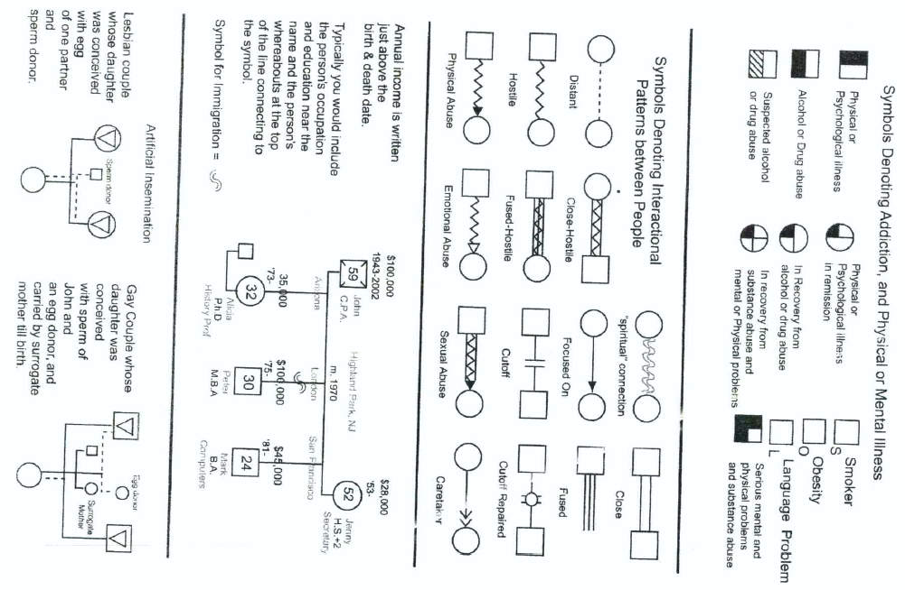

At a Glance
Appendix

At a Glance

Emotions and Feelings - A List of Choices

- absorbed  - abusive  - accepting  - accommodating  - accomplished  - adaptable  - adversarial  - aggressive  - agreeable  - alert  - altruistic  - analytical  - angry  - annoyed  - antagonistic  - anxious  - approved of  - arrogant  - ashamed  - authentic  - balanced  - beautiful  - belligerent  - bereft  - bitter  - bored  - brave  - broken down  - bullied  - calm  - chaotic  - cheerful  - cold  - commanding  - compassionate  - competitive  - complaining  - conceited  - condemned  - confident  - conflicted  - confused  - conservative  - content  - controlled  - controlling  - cooperative  - courageous  - cowardly  - creative  - critical  - cruel  - curious  - defeated  - deluded  - demanding  - dependent  - depressed  - desperate  - destitute  - destructive  - detached  - dignified  - disconnected  - discouraged  - disgusted  - dominated  - dominating  - eccentric  - ecstatic  - egocentric | - egotistical  - empathic  - empowered  - envious  - erratic  - excited  - expressive  - extroverted  - fair  - faithful  - fearful  - frightened  - frustrated  - glad  - good  - grateful  - greedy  - grieving  - guilty  - happy  - harmonizing  - hatred  - helpful  - helpless  - hesitant  - hopeless  - idealistic  - ignorant  - impatient  - important  - impoverished  - impulsive  - indifferent  - individualistic  - inert  - insecure  - insensitive  - inspired  - in service  - interested  - intolerant  - introspective  - invulnerable  - irresponsible  - irritated  - isolated  - jealous  - joyful  - judged  - judgmental  - lazy  - likable  - lively  - lonely  - lost  - loved  - loving  - mad  - manipulated  - manipulative  - mediating  - miserable  - mistrusting  - moody  - moral  - negative  - noble  - obsessed  - open  - panicked  - paranoid | - passionate  - passive  - peaceful  - perfectionist  - pitiful  - pleased  - poor  - possessive  - powerful  - practical  - preoccupied  - procrastinating  - proud  - punished  - punishing  - purposeful  - rage  - reactionary  - reclusive  - rejected  - rejoicing  - repressed  - resentful  - resigned  - resistant  - responsible  - ridiculous  - righteous  - ruthless  - sad  - sadistic  - secretive  - selfish  - self-accepting  - self-condemning  - self-defeating  - self-destructive  - self-hatred  - self-obsessed  - self-pity  - self-sabotaging  - sensitive  - serene  - shamed  - shut-down  - shy  - sorry  - stable  - stimulated  - stricken  - strung-out  - stubborn  - superior  - tantrums  - timid  - tolerant  - unconcerned  - understanding  - unforgiving  - unhappy  - unresponsive  - untrusting  - vain  - vengeance  - vicious  - victimized  - violent  - visionary  - well-meaning  - wise  - withdrawn  - worthy

Love is the ability and willingness to allow those that you care for to be what they choose for themselves without any insistence that they satisfy you…………..Wayne Dyer

Introductory Stems to Start Goals, Objectives and Open-ended Questions
Stems to start long term goals…
To improve… | To stabilize… | To discover… | To understand… | To establish…
To foster… | To communicate… | To utilize… | To motivate… | To strengthen…
To explain… | To build… | To explore… | To develop… | To maintain…
To implement… | To increase… | To enhance… | To educate… | To except…
To resolve… | To achieve…

Action verbs for learning objectives…
Abstract | Activate | Acquire | Adjust | Analyze | Appraise
Arrange | Articulate | Assemble | Assess | Assist | Associate
Breakdown | Build | Calculate | Carry out | Catalog | Categorize
Change | Check | Cite | Classify | Collect | Combine
Compare | Compute | Contrast | Complete | Compose | Compute
Contrast | Convert | Coordinate | Count | Criticize | Critique
Debate | Decrease | Define | Demonstrate | Describe | Design
Detect | Develop | Differentiate | Direct | Discuss | Discover
Distinguish | Draw | Dramatize | Employ | Establish | Estimate
Evaluate | Examine | Explain | Explore | Express | Extrapolate
Formulate | Generalize | Identify | Illustrate | Implement | Improve
Increase | Infer | Integrate | Interpret | Introduce | Investigate
Judge | Limit | List | Locate | Maintain | Manage
Modify | Name | Observe | Operate | Order | Organize
Perform | Plan | Point | Predict | Prepare | Prescribe
Produce | Propose | Question | Rank | Rate | Read
Recall | Recommend | Recognize | Reconstruct | Record | Recruit
Reduce | Reflect | Relate | Remove | Reorganize | Repair
Repeat | Replace | Report | Reproduce | Research | Restate
Restructure | Revise | Rewrite | Schedule | Score | Select
Separate | Sequence | Sing | Sketch | Simplify | Skim
Solve | Specify | State | Structure | Summarize | Supervise
Survey | Systematize | Tabulate | Test | Theorize | Trace
Track | Train | Transfer | Translate | Update | Utilize
Verbalize | Verify | Visualize | Write

Stems to start open-ended, positively stated therapeutic questions
Clarify | Describe | Elaborate
Explain | Explore | Help me to understand
How | Paint me a picture | Share
Talk about | What | What does
What else | Tell me
Case Studies
Instructions: Use the following case studies for the case application worksheet, case vignettes, mind mapping, and question development worksheets.
JACK: Afraid that he is “empty inside”
This statement was written by one of my students in an internship program. At the time he wrote it, he was undergoing both individual and group counseling.
“Most of my life I have felt pushed and pulled. My father pushed me into school, sports, and so forth, and over the years my resentment grew for him, as he was always directing and controlling my life and beating me when I challenged his authority. My mother always gave me a warm, unconditional love and tried to pull me under her protective wing, something I have always resisted.
“My parents divorced when I was 16, and without parental control I began a life of permissiveness in my relationships with women and in my use of psychedelic drugs and marijuana.
“On graduating from college, I rejected my father’s wishes to pursue a career and returned to school to seek another degree. In some ways it’s just a place to be that I like. Most of my life revolves around living for today, a hedonistic style that has no concreteness of goals and aspirations, with a lack of definition of `what a man should be.’
“I float in and out of people’s lives. They see an image of me as a despoiler of women, a drug freak, and a cold bastard. My fear is that I am nothing more than that image, that I am empty inside. I want to be able to open up and let people see the warmer, more sensitive sides of me, but I have terrible difficulty doing that. I have a strong need to become close and intimate with others, yet I never let myself become vulnerable because I fear being dependent on them and trapped by their love.”
JULIE: “It’s my father’s fault that I can’t trust men”
Julie is interested in exploring her relationships with men. She says that she cannot trust me because I am a man and that she cannot trust men because her father was an alcoholic and was therefore untrustworthy. She recalls that he was never around when she needed him and that she would not have felt free to go to him with her problems in any case, because he was loud and gruff. She tells me of the guilt she felt over her father’s drinking because of her sense that in some way she was causing him to drink. Julie, who is now 35 and unmarried, is leery of men, convinced that they will somehow let her down if she gives them the chance. She has decided in advance that she will not be a fool again, that she will not let herself need or trust men.
Although Julie seems pretty clear about not wanting to risk trusting men, she realizes that this notion is self-defeating and would like to challenge her views. Though she wants to change the way in which she perceives and feels about men, somehow she seems to have an investment in her belief about their basic untrustworthiness. She is not very willing to look at her part in keeping this assumption about men alive. Rather, she would prefer to pin the blame on her father. It was he who taught her this lesson, and now it is difficult for her to change, or so she reports.
Doris is considering leaving her husband and her child, although she is uncertain how she would continue to support herself financially. She is also concerned with what would happen to her son, because her husband has no means of support. She insists that she does not want to take the child with her.
References
Corey, G. (2009). Theory and practice of counseling and psychotherapy (8. ed.). Belmont, Calif.: Thomson Brooks/Cole.
Emotions and Feelings – A List of Choices.. (n.d.). Personal Development | Create a plan to know, heal and expand yourself. Retrieved August 13, 2012, from http://www.higherawareness.com/self-healing/emotions-and-feelings.html
Multicultural Family Institute —. (n.d.). Multicultural Family Institute —. Retrieved August 13, 2012, from http://multiculturalfamily.org/

